Dream Bricks

Abstract

* Introduction to the project
* Explaining Workflow
* Technologies used
* Further developments (additional things can be completed)

**Done by (Team no. 6)**

Hashwanth

Harish

Suhail Ahmed Khan (17Z250)

Surya Anand (17Z251)

Sundeep Charan.R (16Z256)

## Introduction :-

Dream Bricks is a fictional American based online real estate application, to help people look for properties. Each part of the website is dynamic and data driven.

## Explanation of the workflow (wireframes) :-

The user is first welcomed with a landing page, displaying the who and what questions of the website along with two call to action buttons to signup or to sign in. It further moves on with the features and the customer testimonials of the website along with the FAQ and Contact us footer, with a logo.

**Landing page**

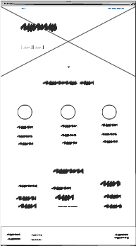

The header region serves as the navigation bar allowing us to sign in and view the generic pages. About, Contact us, etc.

The Login Page, and the signup page has both normal email method as well as OAuth methods, through Facebook.

After the registration and the login process we arrive to the homepage, Where the user is free to search the listings in his area by name, location, number of bedrooms, bathrooms, garage facility, etc:-.

The website also shows the top three listings in that area of that month below the search bar, to facilitate the users for easy access, and to make them to know the popular real estates around that locality.

**Signup page**

**Login page**

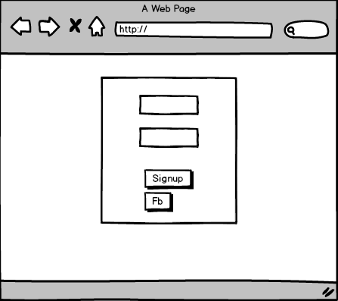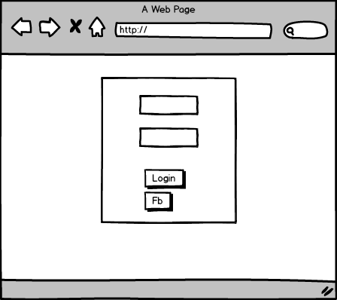

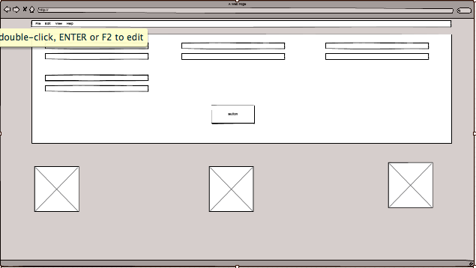

**Home Page**

User is welcomed to view the listings through the results searched before. These listing can further be filtered with respect to the share feet and bedrooms, furnished or not etc with the help of side navigation bar separated for the filters, and each listing can be viewed individually in the detail view. User can then enquire directly to the posted person, by submitting their forms. If the user is a guest user, he/she should enter his crucial credentials, such as name, address, locality, etc. Else the website automatically retrieves the name of the logged in user, and it auto fills.

**Listing Brief view**

**Listing Detail view**

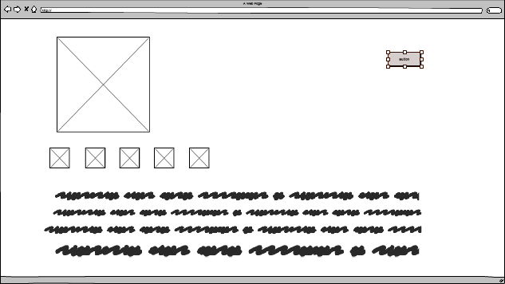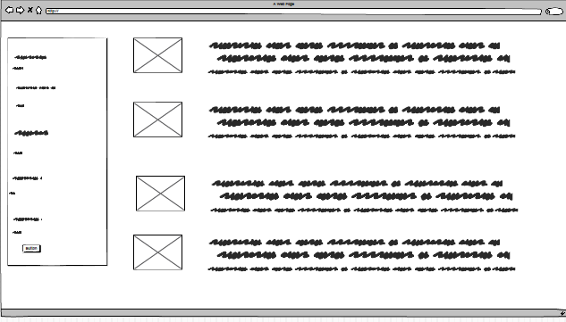

Upon successful submission of the enquiry, an email is sent to the person who posted the ad, in order to notify that someone is interested to view further details of that particular property.

The User can view his dashboard to check his respective inquiries, his password reset, change and edit his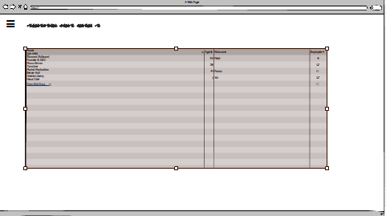

**User Dashboard**

basic information, or even upload

further details like photo

and secondary information

like occupation etc.

## Technologies used :-

**FRONT END :-**

HTML5 - for the structure and the backbone of the website.

CSS3 - for the design and the layout of the website, to look aesthetically pleasing.

Bootstrap 4 - for responsive web design across multi devices (phone, laptop, desktop).

**BACK END :-**

Django - the framework written in Python to handle requests (GET, POST, PATCH, DELETE), and to dynamically load the website pages.

PostgreSQL - an object relational database used to map the data between the users and the listings etc. Prominently used to store voluminous data.

**Further developments :-**

Enquiry can not only be filled in a form, but can indulge in a chat with the user who posted, directly.

Implementation of posting ads (either rent or sell) by users . **This feature is not added in introduction due to the complexity for implementing this within the given time frame.**

After the posting of ad by the user, he/she can make her ad move upwards through the entire listing rows by paying a small fee (Payment gateway implemented by stripe API).